1. 
2. Let’s see how **HashMap** and **Hashtable** Data Structure work internally and how they are super-fast.
3. When putting key, value in hash map or table, where it is stored?
   1. Internally, they maintain array.
   2. Each value is mapped to some array index.
   3. This is the job of Hash function to map value to array index.
   4. So, hash function takes a number and map that to array index which we call depending on the context.
      1. Hash Value.
      2. Hash Code.
      3. Digest.
      4. Just hash.
   5. Key is mapped to array index.
4. 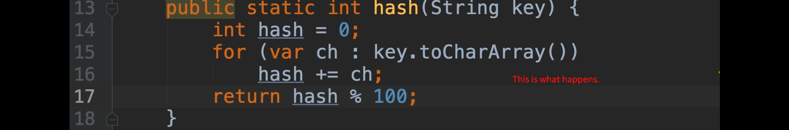
5. 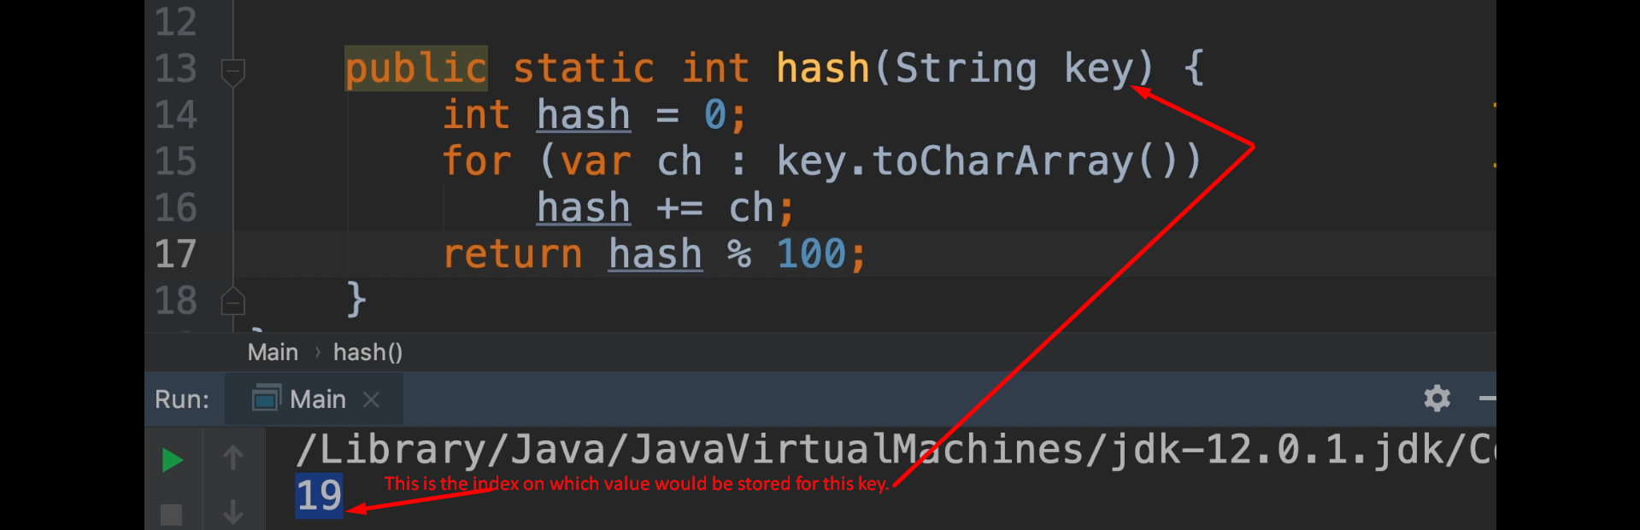
6. 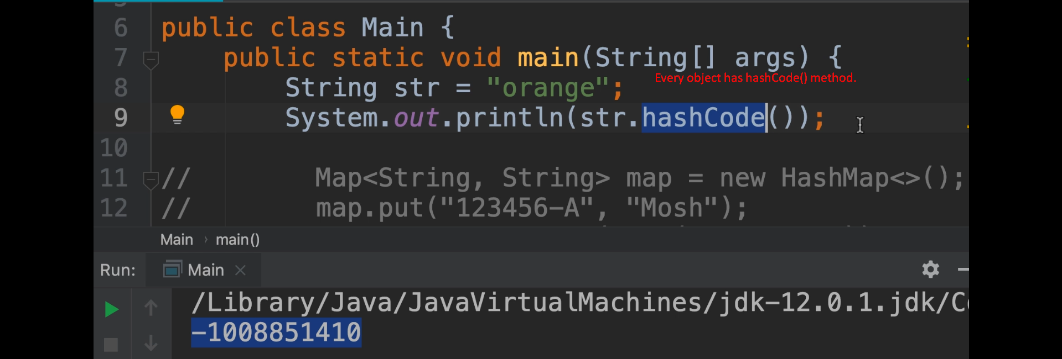
7. There are other kinds of hash functions such as hash function used in cryptography where password is not stored as plain password but it is hashed to generate some very long string.  
   But in our case (HashMap, Hashtable), we want hash function which maps key to array index.